Perceptions of Crime On Campus

Nicholas C. Lario

La Salle University

Abstract

Since the tragic murder of Jeanne Clery in 1980, there has been an increased interest in crime on college campuses. This growing interest has created a more complete public picture of crimes being committed on campus (e.g. annual safety reports and emergency text notification); however, despite this increase in information it is not clear if students have an accurate representation and knowledge of where crime occurs. Specifically, this research sought to understand how accurately college students identify high crime areas on and near their campus. This study used recorded crimes on campus, survey the geographical perceptions of students (n = 30) regarding crime on campus and visualized crime and student perceptions of crime with a geographical information system GIS. Results suggested students had a generally accurate perception of where crime occurs on campus. La Salle Security alerts and Philadelphia’s Police Department had similar records of crime around La Salle’s campus. From that, we found that students mostly agreed on where the high crime areas were on campus. Although there were multiple people who noted the entrance to south campus as a high crime area, the Philadelphia Police Department, as well as La Salle Security, did not have records which supported that. Results might help inform the utility of the crime dissemination on college campuses.

History

On the date of April 5th Jeanne Clery was a freshman, at Lehigh University living in Stoughton Hall at the time, she went to sleep with the door unlocked because her roommate had forgotten her key. It was on this night that Josoph M. Henry entered Stoughton Hall through a propped open door, entered Jeanne Clery’s unlocked room, and proceeded to rob, beat, cut, rape, sodomize, and strangle Jeanne (Justia, 1997). This was the culmination of many previous incidents of insufficient security and reporting on Lehigh’s campus. Her death led to a public outcry towards insufficient reporting, alerting, and protection on college campuses. In addition to this, allegations of rapidly increasing crime began to plague Lehigh University. Following this incident, Jeanne’s parents lead the movement for legislative change, which came in the form of the Clery Act, enacted in 1991, 5 years after the death of Jeanne Clery.

Jeanne Clery’s death caused an increasing concern about campus crime, yet despite this increased focus on campus crime it is not clear if college students are aware of the level and location of crime on campus. This research seeks to understand how accurately college students identify the location and level of crime on their campus, and to discern what factors if any, distort their perceptions.

**Main Features of Clery Act**

The tragedy of Jeanne Clery lead to improved reporting of on-campus crime and create more transparency. The Clery Act has four primary requirements for colleges that take part in federal aid programs. These requirements include an Annual Security Report, Crime Log, Timely Warnings, and Crime Statistics. Over time the Clery act has been amended to broaden what it covers in an attempt to increase its effectiveness. The four main aspects of the Clery Act include:

*Clery Act- 20 U.S. Code § 1092 - Institutional and financial assistance information for students*

1. Annual Security Report- This requires colleges and universities that fall under the Clery Act to release a yearly report before October 1st. It must include crime statistics for the previous three years as well as crime reporting, campus facility security and access, law enforcement authority, the incidence of alcohol and drug use, and the prevention of/response to sexual assault, domestic or dating violence, and stalking. (Clery Center 2017)
2. Crime Log- Campus police and security must keep a daily crime log of alleged criminal incidents
3. Timely Warnings- Provide a timely warning about crimes that pose or continue to pose a threat to safety. In addition, this policy must be disclosed in the annual security report.
4. Crime Statistics- This requires logged criminal statistics such as number of hate crimes or total number of arrests.

Campus Crime

Campus Crime is a broad topic (e.g. sexual assault on campus, crime committed near campus, students, perpetrators, and victims, etc.) that as noted above did not receive extensive attention in the United States until the 1980s. Most notably, through the Clery Act, more transparency has been required from college institutions about recorded crime on campus. As previously stated, there was little research and knowledge about campus crime prior to the Clery Acts creation. Yet what we do know is that modern crime trends across the United States rose into the 1980s and have been steadily declining since. Through this we can not only attempt to compare crime rates on college campuses to national crime rates, but we can compare modern-day college perceptions of crime with national perceptions of crime. In addition, we can see how accurate our perceptions are for both views by comparing them to recorded crime levels.

Campus crime

*History of Campus Crime*

When discussing the History of Campus Crime it is important to note that records of campus crime are inconsistent at best prior to the Clery Act. Some studies have been created though, such as a study by the NCES which goes back to 2001 through 2014 and includes a notable decrease in crime.

*Between 2001 and 2014, the overall number of reported crimes decreased by 35 percent. Although the number of reported on-campus crimes increased by 7 percent between 2001 and 2006 (from 41,600 to 44,500), it decreased by 39 percent between 2006 and 2014 (from 44,500 to 27,000). The number of on-campus crimes reported in 2014 was lower than the number reported in 2001 for every category except forcible sex offenses.5 The number of reported forcible sex crimes on campus increased from 2,200 in 2001 to 6,700 in 2014 (a 205 percent increase).* (NCES 2017, para. 3)

Some research indicates there has been an increase in school violence activities, such as a study from the School Violence Resource Center which showed that the percentage of high school students who were threatened or injured with a weapon increased from 1993 to 2001. However, it is unclear if college and university trends mirrored those of studies focused on high school students. Other research notes decreases in student victimization rates for both violent and nonviolent crimes during a similar time period of 1992–2002 (FBI UCR 2014).

Focusing on colleges and universities, overall they appear to be safe places (with the exception of sexual assault and rape) and have only gotten safer over time. An example of this would be a 2014 study performed by the U.S. Department of Justice. This study used the National Crime Victimization Survey to compare rape and sexual assault rates between college-age women. This study found that college-age women attending college had consistently lower rates of sexual assault and rape when compared to college-age women not attending college. In addition to this, both groups had a relatively consistent decrease in victimization each year. (2014, Sinozich, Langton). Through the studies that do have data going back over extended periods of time (pre-2000s) there appears to be a trend of campus’ becoming safer. This can be explained through multiple different factors; including campus police becoming more effective/professional, a nationwide trend of decreasing crime, and policy changes that make offenses more likely to have consequences (Fernandez 1993).

In addition to examining levels and trends of reported crimes, it is also important to acknowledge that perceptions of crimes, that is actual crime rates, the amount of attention the media dedicates to crime or levels of disorder (not crime) are just some examples of factors that impact an individual’s estimation of crime levels and subsequent fear.

*Perceptions of Crime*

When considering perceptions of crime, many studies have found that the average American has an inaccurate view of crime levels. An example of this would be a recent Gallup poll conducted in 2010 in which 2/3rds of Americans feel that crime has been steadily increasing (Jones 2010); yet crime had been steadily decreasing from the mid-1990s until 2010. This is one of numerous examples in which the average American has a misconstrued view of the crime levels. In addition to this, a tracking poll of 2000 American voters found that not only did most Americans think that crime has gotten worse over the last two decades, but 43% would consider there to be “much more” crime than two decades ago. When comparing that to publically released crime data, we see that the opposite is true. The Brennan Center released a report on American crime trends and found that “The national crime rate peaked in 1991 at 5,856 crimes per 100,000 people, and has generally been declining ever since. In 2015, crime fell for the 14th year in a row. Estimates based on preliminary data for 2016 indicate that the overall crime rate will remain stable at 2,857 offenses per 100,000, rising less than 1 percent from 2015. Today’s crime rate is less than half of what it was in 1991”. Through this, we can see that contrary to public opinion, today is a far safer time than much of the last two decades. This leads us to the question; Why are our perceptions so inaccurate? And do students have accurate perceptions of crime on a college campus? (Friedman 2017)

Crime rates have varied much throughout modern history. From a dramatic crime spike during the 1970s and 80s, to the notable decrease in crime leading all the way up to the last three years. Yet through these crime peaks and lulls, our perceptions of crime are rarely accurate. The inconsistency of our perceptions are due to a multitude of factors including the media. A study by Kenneth Dowler investigated the effect media has had on our perception of crime. Specifically, he investigated if fear of victimization and expected crime levels are affected by the media. His research lead him to find that, “Presentation of large amounts of local crime news engenders increased fear among the larger public” (Dowler 2003). In addition to this, news media had a greater effect when direct experience was lacking. “ For example, Liska and Baccaglini (1990) found that media influence was strongest for females, whites, and the elderly, which are segments of the population least likely to be victimized. In another study, Chiricos et al (1997) find that the frequency of watching television news and listening to the news on the radio is significantly related to fear.”

In addition to this, the media not only affects our perception of crime, but affects certain crime perceptions more than others. An example of this would be how, “Examining the National Opinion on Crime and Justice (NOCJS), Haghighi and Sorensen (1996) find that local media attention to crime was significantly related to fear of sexual assault; getting mugged, beaten up, knifed or shot; and being burglarized while at home. Fear of crime was not significantly related to fear of carjacking, being murdered, or being burglarized while not at home”. It is also important to note that the type of media effects the changes in our perception. Such as how crime shows are included in this research, and those who view crime shows regularly, “In addition, their findings indicate that crime show viewers were more likely to worry about being sexually assaulted; getting beaten up, knifed or shot; and getting killed.” (Dowler, 2003, p. 110-111) This would be due to those being primary topics within crime shows; this carries over to media as a whole because they focus on attention-grabbing crime incidences. The theory that embodies this belief would be the Cultivation theory, which is the belief that the more time people spend watching t.v. or observing (social) media, the more likely they are to believe that social reality aligns with the reality they observe from the media (Dowler 2003). Misconceptions about crime are not just limited to the general public but research has even suggested that police officers might not even be keenly aware of the nature and location of crime in the areas they work.

In between February and April of 1998 researchers asked65 officers making up 80% of the Nottinghamshire police department to answer a survey involving crime hotspots (areas with elevated levels of crime). These officers were all operational in street duties at the time. The survey pertained to their individual subdivision and requested they mark down locations of concentrated criminal activities. The officers were also provided three types of high volume crimes to specify, including vehicle crime, residential burglary and non-residential burglary. Results were unique to each subdivision of officers. Officers commonly viewed vehicle crime as a random inevitability while burglaries were preventable. Bias was shown to specific areas where officers personally dealt with crime, regardless of general trends. Yet the officers were shown to have strong correlation rates with burglary hotspots (Ratcliffe and McCullagh, 2001).

In sum, it is clear the general public overestimates crime levels and in some cases, the police officers are not clear regarding the location of crimes in the areas they patrol. Considering the wide misconceptions of crime levels and locations, despite the efforts of the Clery act it is not clear if college students have misconceptions.

Unanswered questions

This current study attempts to extend research on-campus crime and perceptions of crime. Since research has demonstrated that people are not particularly apt at indicating crime trends and the location of crime, but after the passing of the Clery Act more information is available about crime on campus. Overall, it is not clear if student’s perceptions of crime locations align with the location of reported crime. The current research attempts to fill this gap.

Data and Methods

Study site

La Salle University is a Private, Roman Catholic University located in Philadelphia, Pennsylvania. It is a relatively small school with approximately 5,197 enrolled students of which 44% live in on-campus housing. The University is largely female with 62% of the student body being female. With a higher level of crime than many other University’s it is important to consider its location, of which Philadelphia as a whole has a higher crime rate than much of the rest of the country.

Campus Crime (La Salle specific)

La Salle University Campus Crime -Annual Security Report

Within the Annual Security Report that La Salle University produces every year due to the Clery Act, we can observe all reported crimes on campus (La Salle Public Safety 2017). Specifically, the total number of reported crimes for the years of 2014, 2015, and 2016 are 331, 299, and 225. Comparatively, when viewing it through an index of 100,000 students, these numbers are 4385, 4090, 3564. Using this publicly available information, websites such as <https://ope.ed.gov/campussafety/#/>, allows users to view these Annual Security Reports as well as comparing these rates from year to year. Using this website I compared criminal offenses per 100,000 students at La Salle University over the years of 2013, 2014, and 2015.

La Salle University Crime Rate (per 100,000 students)

Criminal Offense 2013 2014 2015  
a. Murder/Non-negligent manslaughter 0 0 0  
b. Negligent manslaughter 0 0 0  
c. Sex offenses - Forcible 3 0 0  
d. Rape 0 0 5  
e. Fondling 0 0 1  
f. Sex offenses - Non-forcible 0 0 0  
g. Incest 0 0 0  
h. Statutory rape 0 0 0  
i. Robbery 1 0 2  
j. Aggravated assault 1 3 1  
k. Burglary 2 2 2  
l. Motor vehicle theft 0 0 1  
m. Arson 0 0 0

These crime rates are similar to other Philadelphia school crime rates, yet La Salle had a seemingly higher rate of motor vehicle theft, robberies, and rape, yet comparatively lower levels of aggravated assault and burglary. In addition to this, we can accurately determine crime trends over the last three years per each annual security report. This can be used to not only foresee directional crime trends but also would allow observers to analytically compare changing policies within the University/security and its effect on crime rates. Using the Annual Security Report of 2017, the total reported criminal offenses for the years of 2014, 2015, and 2016 are 331, 299, and 225. When adjusting for the ever-changing populations, these totals would be 4385.5, 4090, 3564 per 100,000 students. From this, we can deduce that La Salle has had a steady decline in crime over at least the last 3 years.

*Survey and Data*

This research included an IRB approved anonymous survey (see Appendix A) through a convenience sample of students on main campus. Thirty students were asked to complete the 5-7 minute survey which included personal factors including gender, housing, and year at La Salle. For sample characteristics see table one.

|  |  |
| --- | --- |
| Table 1: Characteristics of the respondents | |
| Total respondents | N = 30 |
| Current academic year |  |
| Freshman | 9 |
| Sophomore | 8 |
| Junior | 8 |
| Senior | 5 |
| Do You Commute? |  |
| Yes | 17 (7 live directly off campus) |
| No | 13 |
| Home residence population |  |
| Rural | 1 |
| Town of <100,000 | 8 |
| Town between 100,000-500,000 | 4 |
| A large city | 17 |

They were then asked to identify three high crime locations on a campus map, and three high crime locations not including buildings (see appendix A for survey). The location of crime was culled from two sources. Using ArcMap by ESRI, a common geographic information system (GIS) the location of each La Salle University security alert was mapped for the 2017 Fall academic year. These alerts are sent and posted on a university portal at the discretion of the administration and while a variety of factors dictate if an alert is posted they are generally for situations when it is deemed that the campus community needs to take immediate action to remain safe. These were selected as a source of data as most, if not all students are aware of these events and might stand out as especially prominent events. The other source consists of crime data from the Philadelphia Police Department via PHL Crime Mapper. In an effort to provide additional transparency and more data to the public the Philadelphia Police Department provides the data, location and crime type for reported crime in Philadelphia. This data was limited to September 2017 to December 2017 and restricted to La Salle’s campus as well as approximately a half-mile buffer area adjacent to campus.

Findings/results

Through the research within La Salle University’s security alerts it was discovered that a strong clustering of recorded crime along the North side of campus. This included completely along the north to both the east and west ends of campus. This goes along with the structure of La Salle in which the majority of dorms and off-campus housing exists around and among the neighborhood on the Northside of campus. The following map displays the location of the La Salle University security alerts sent to students. The content or nature of the alerts include crimes such as vehicle break-ins, reports of gunfire, as well as burglaries and assaults.

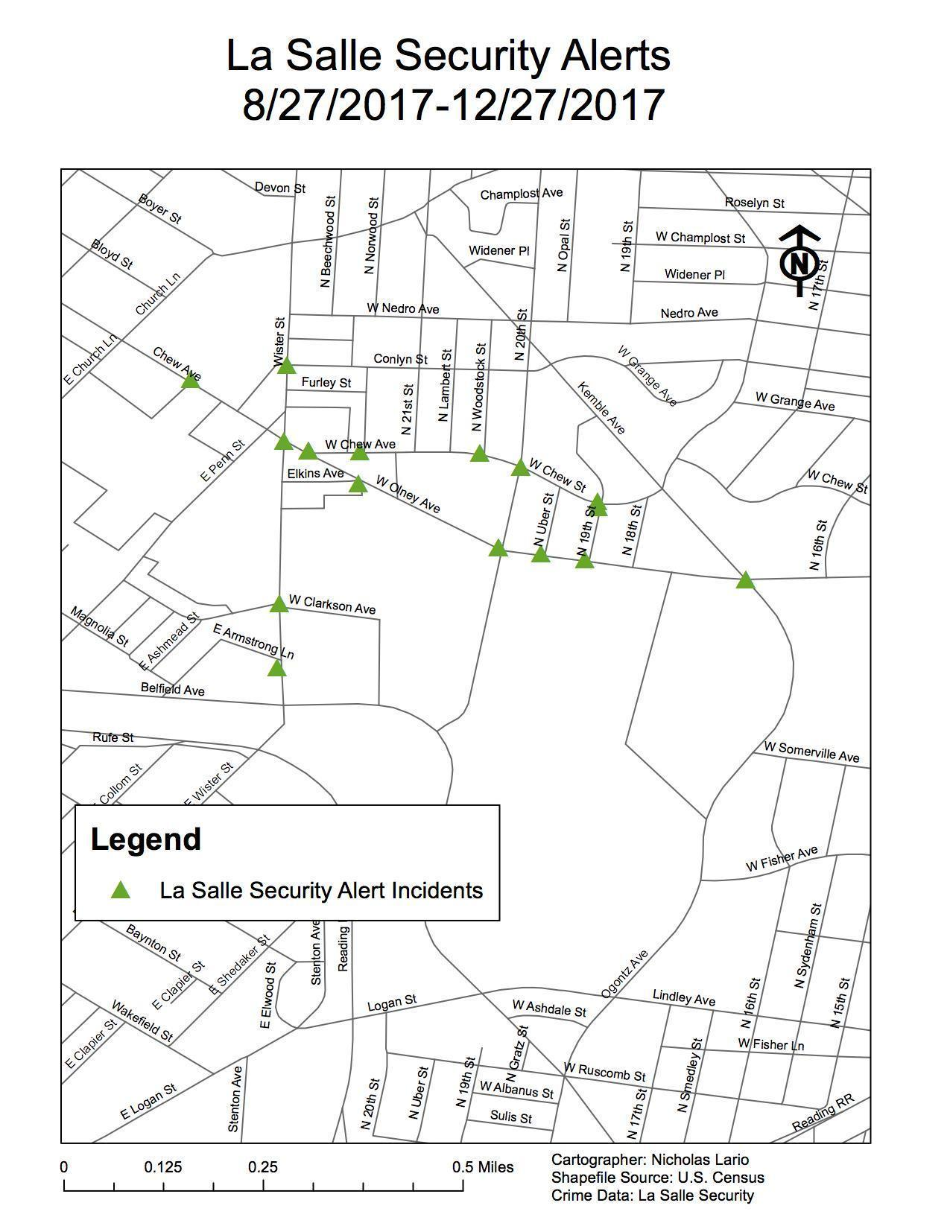

The reported crime gathered from the Philadelphia Police department showed extremely similar crime clusters to La Salle University security, except in greater numbers. Reported crime showed a large clustering along the North Side of campus along the dorms and residential housing as well as the North East and North West sides of campus.

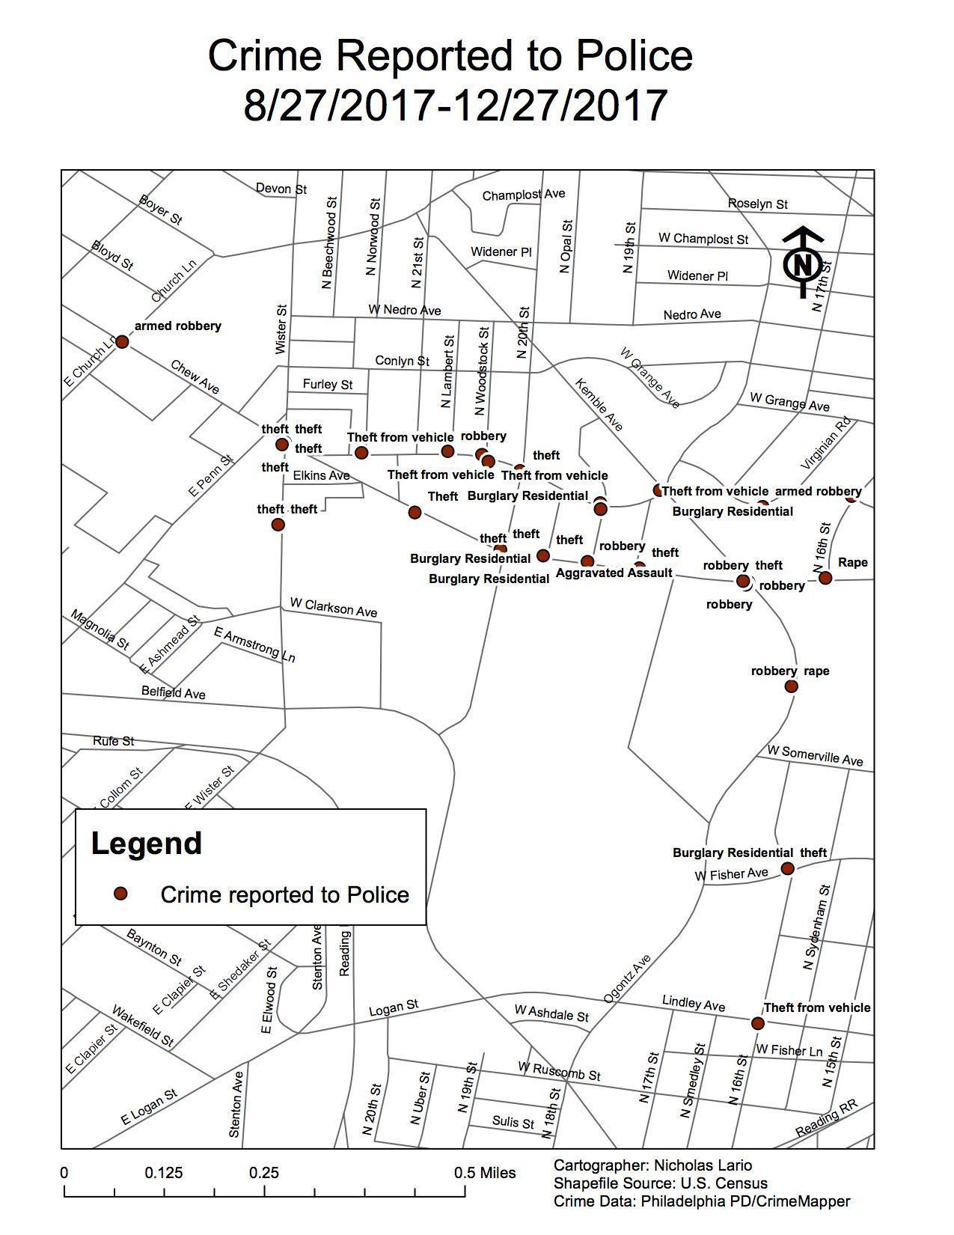

When looking at the combined data of Philadelphia’s Police Department as well as La Salle’s security we can notice a few differences. While both La Salle Security and Philadelphia’s Police Department provided records or crime, the Philadelphia Police provided a greater number as well as extending beyond the exact border of La Salle’s campus. We can assume that a possible reason for the differences in the number of crimes could be that La Salle security never received notice or alerts of crimes committed while Philadelphia Police did, as well as recording crime that occurred off-campus while La Salle security does not.

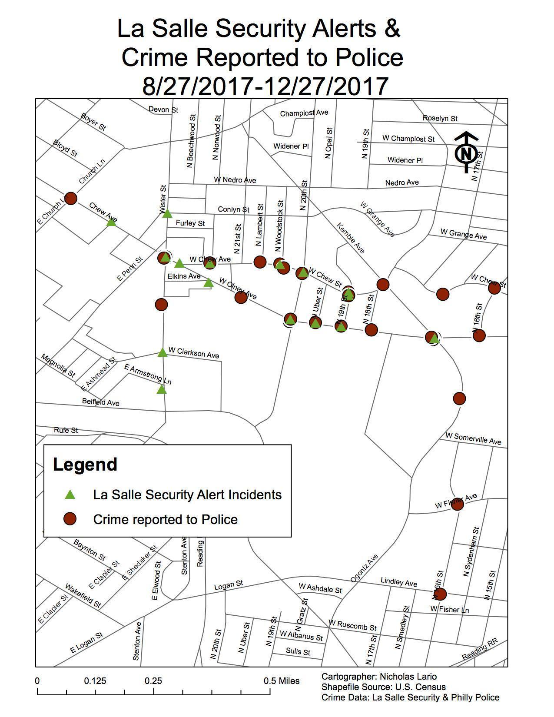

Finally students’ perceptions of high crime areas, which are generally accurate when compared to both La Salle Security and Philadelphia’s Police Department. There was a stronger emphasis on crime in the North East and North West sections of campus compared to a weaker sense of crime from the main North Campus. In addition to that there were notable student perceptions of high crime among the south campus entrance, which had virtually no reported crime by Philadelphia Police or Campus Security. This is likely due to a relatively small police/security presence there, in which only one guard is stationed. In addition to that, there is a smaller student population living on south campus and virtually no students living off-campus down south. While North campus has a larger security force present, a larger student population, and a larger off-campus community. This could mean that while security may not have to increase along south campus, perhaps better lighting could lower perceptions of crime and allow students to feel safer. It is also worth noting that the few people who would mark south campus likely lived among the two south campus dorms. In addition to that, one-third of the reports of south campus came from freshman, which would make sense in regards to the freshman only dorm ‘Neumann’ along the south campus entrance. Furthermore, if we are to use this information to improve any aspects of security we would likely see the high perception/high crime area along north campus and try to increase security along there. Another aspect which La Salle Security may be interested to act on would be how the Shoppes of La Salle and the Olney Transportation Center had far too high perceptions of crime as well as recorded crime. There should be an increased security presence at or near the Transportation Center, and the fact that the Security Headquarters on campus is located within the Shoppes of La Salle means they must increase their presence in the area. Improved lighting throughout the parking lot within the Shoppes may help lower the appeal of crime in the area. Outside of the Shoppes there was also an extremely high level of student perceived crime as well as recorded levels from La Salle security and the Philadelphia Police. This is a location that is slightly closer to the center of campus then the Shoppes yet has similar levels of perceived crime and recorded crime. This is likely due to the two dorms along the intersection of Olney and Wister at this location. We could attempt to lower the perceived and actual levels of crime by staffing more than the only one security booth in the area which is often not staffed. Improved lighting and security presence could make the students living in the two dorms feel safer while also making crime less appealing in that area. The last high perceived and high recorded location on campus would be the center of north campus along the North Halls complex. This area is often adequately staffed as well as well lighted. Yet a likely reason this area remains high in crime would be the high level of interaction between people at these locations. Due to the fact that the largest dorm complex on campus as well as the majority of off campus houses are found in this location, in addition to being interwoven with the local community makes this a highly interactive area. This likely has created this spike in crime compared to much of the rest of the campus. This situation makes methods to lower crime more elusive. Possible efforts which could lower crime in the area could be the installation of security cameras along certain sections of north campus, as well as continuing to instill awareness in the students to be alert while walking between locations and to keep valuables out of sight. Yet this is already a commonly instilled lesson by La Salle security such as how it is included at the end of most of their security reports. This raises the question of how can we better teach this lesson to students.

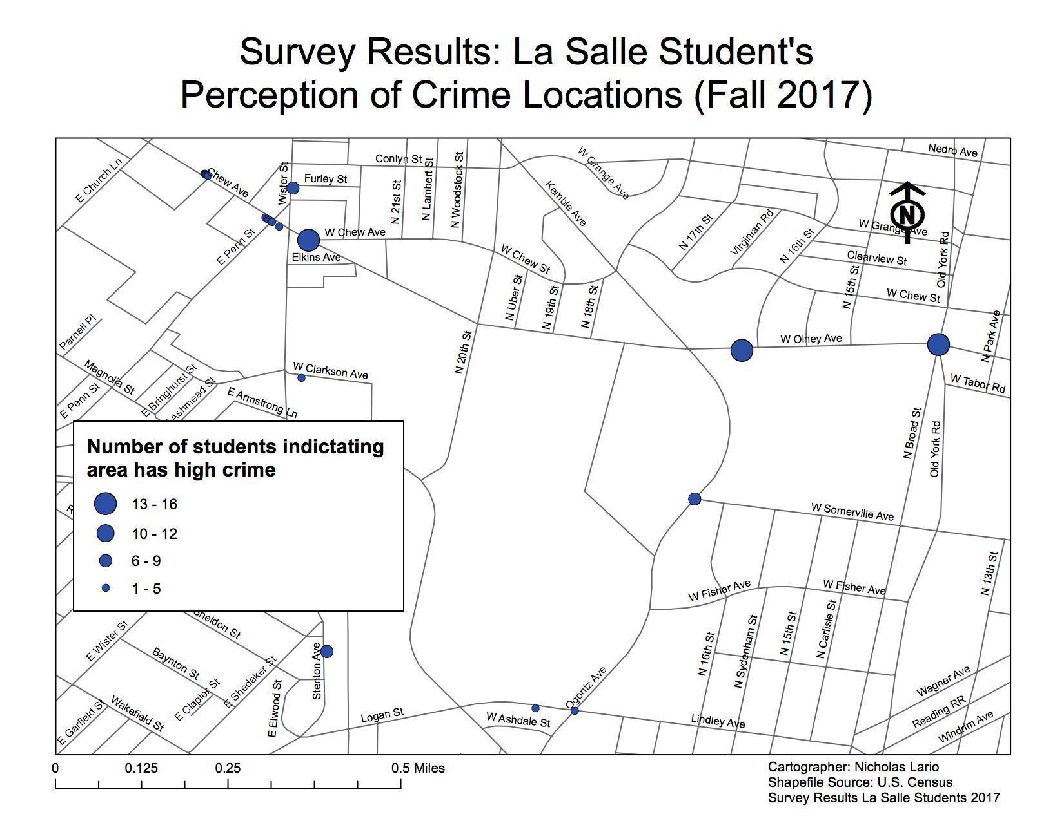

**Discussion**

Unlike prior research (Ratcliffe and McCullagh, 2001) students had a relatively accurate perception of where crime occurred. Although it is not clear why students were fairly accurate relative to others identified in prior research concerning the location of crime, it is possible the Clery Act, and its notification requirements, coupled with the moderate-sized student body made students well informed regarding crime events.

There was a notable amount of students who perceived the entrance to south campus as high crime which had virtually no recorded crime by La Salle Security or Philadelphia Police. In one of the few instances of the student’s perceptions being notably inaccurate, we can reasonable assumptions for how they came to that conclusion. Along our south campus there are only two dorms, which are composed largely of freshmen, and in addition to that, there is very little security presence. While south campus is very safe as it is relatively closed off, it does not have the visible presence of security the way all of north campus has, nor the far larger student population. Due to that, a student who lived in one of those two dorms may feel that south campus is not a comparably safe place on campus.

The results of this study show us that students are largely aware of these high crime areas, but this raises the question of how does this impact their lives here at La Salle University. These perceptions may limit the desire for students (especially around north dorms) to travel late at night. In addition to that, students may walk around with a general sense of insecurity, especially in certain situations.

The findings must be considered in light of some considerable limitations. First, results are based on a convenience sample, perceptions might be different if a representative sample was used. Although, a convenience sample was used, efforts were made to survey a broad array of student (equal males/females, varying grade levels, and those living on and off-campus).

Additionally, crime was based on Philadelphia Police Department Data (via CrimeMapper) and La Salle Alerts – this doesn’t include crime that is not reported. Considering reports of rape are high on college campuses (Rainn 2018) these types crimes, often committed by someone the victim knows do not seem to be accounted for in this study.

Future research should consider asking specifically where they currently and have previously lived on campus, or the approximate area, to see if there is any location bias to where these high crime locations are. In addition to that, additional questions on how often students read the security alerts and how they become aware of them may be interesting to see if there is any correlation to where they perceive to be high crime areas. Finally, perhaps a question to directly investigate their perceptions, such as why do they feel these areas have high crime compared to the rest of campus.

Results from this research found that students generally agree upon where the high crime areas on campus would be. When addressing the top crime hotspots chosen by students surveyed, males and females both generally agreed on where they felt unsafe. It was interesting to see a notable marking on the south campus entrance which has virtually no crime, but that is likely contributed to living in one of the few dorms on south campus which has a small security presence. In addition to that, women had a slightly higher amount of crime perception on the streets along the way to the Olney Transportation Center and the Shoppes of La Salle. While the crime in this area was no worse than sections of north campus that students walk through every day, the long distances and light security presence when in route to these destinations may increase a sense of fear and insecurity. Limitations of this study include how students had trouble identifying La Salle’s layout on the map provided for the survey. This possibly affected some of the results, as there were multiple points marked as high crime areas that were not close to campus; and those responses were not used.

Appendix

Optional Survey for LaSalle Students; all questions are optional, the survey answers will be used as data for Research on campus.

Q1. What is your gender?

A. Male

B. Female

Q2. Do you commute?

A. Yes

B. No

Q3. If you commute do you live directly off campus?

A. Yes

B. No

Q4. When I am not attending La Salle, my home residence is

A. A rural area

B. A small town of less than 100,000

C. A medium size town between 100,000-500,000

D. A large city

Q5. What is your current year at La Salle?

A. Freshman

B. Sophomore

C. Junior

D. Senior

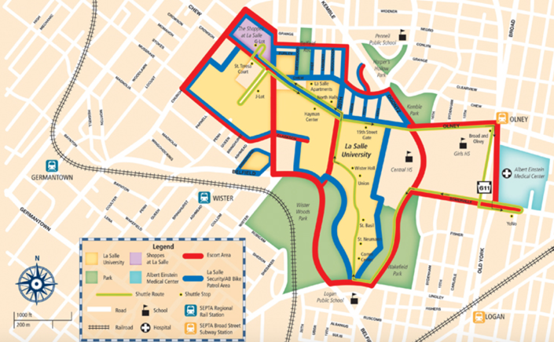

Q6. Please indicate 3 areas on campus that you would consider crime most likely to be occur?

(violent as well as non-violent crime)

Q7. Please indicate 3 areas on campus (not including campus dormitories and facilities) where you would consider crime most likely to occur?

(violent as well as non-violent)

References

1. Clery Center (2018). *Policy and Recources*, from

<https://clerycenter.org/policy-resources/the-clery-act/>

1. Dowler, Kenneth. (2003). *Media Consumption and Public Attitudes Toward*

*Crime and Justice: The Relationship Between Fear of Crime, Punitive Attitudes, and Percieved Police Effectiveness* Retrieved from http://www.albany.edu/scj/jcjpc/vol10is2/dowler.html

1. Emanuelsson, Anette. Romina, Mele (14-03-2004) *The Mean World Syndrome*

Retrieved from http://www.svj.hvu.nl/mediahype/risk4/page2.htm

1. FBI UCR (2010, March 17) *Crime in Schools and Colleges*. Retrieved from

https://ucr.fbi.gov/nibrs/crime-in-schools-and-colleges

1. Fernandez, Adriana. Allan, Lizotte (1993). *What’s Happening To Rates Of*

*Campus Crime.* Retrieved from <https://ropercenter.cornell.edu/public-perspective/ppscan/51/51029.pdf>

1. Friedman, Matthew. [Ames, Grawert](https://www.brennancenter.org/expert/ames-grawert). [James, Cullen](https://www.brennancenter.org/expert/james-cullen). (2017, April 18). *Crime*

*Trends: 1990-2016* Retrieved from https://www.brennancenter.org/publication/crime-trends1990-2016

1. Gover, J. Lane. A. R., & Dahod, S. (2009). *Fear of violent crime among men and*

*women on campus: The impact of perceived risk and fear of sexual assault.Violence and Victims, 24(2), 172-92.* Retrieved from http://dbproxy.lasalle.edu:2048/login?url=https://search.proquest.com/docview/208557718?accountid=11999

1. Gregory, E. Dennis. Steven, M. Janosik. (2002) *The Clery Act: How Effective Is*

*It? Perceptions From the Field— The Current State of The Research and Recommendations for Improvement.* Retrieved from <http://www.stetson.edu/law/lawreview/media/the-clery-act-how-effective-is-it-perceptions-from-the-field-the-current-state-of-the-research-and-recommendations-for-improvement-of-the-act-and-campus-safety.pdf>

1. Jones, Jeffrey. (2010, November 18). *Americans Still Perceive Crime as on the*

*Rise*. Retrieved from

http://news.gallup.com/poll/144827/americans-perceive-crime-rise.aspx

1. Justia Law (1997). *Com. v. Henry*. Retrieved from

https://law.justia.com/cases/pennsylvania/supreme-court/1997/550-pa-346-1.html

1. La Salle Public Safety (2017). *Annual Security and Public Safety Alert.* Retrieved from https://wa3.lasalle.edu/channels/docs/get.php?id=1349
2. National Center for Education Statistics (2016). *The NCES Fast Facts Tool* .

Retrieved from https://nces.ed.gov/fastfacts/display.asp?id=804

1. Nasar, Jack & Fisher, Bonnie & Grannis, Margaret. (1993). *Proximate Physical*

*Cues to Fear of Crime. Landscape and Urban Planning – Landscape Urban Plan.* Retrieved from <https://www.researchgate.net/publication/240433864_Proximate_Physical_Cues_to_Fear_of_Crime>

1. RAINN. (2018) *Campus Sexual Violence: Statistics.* Retrieved from

https://www.rainn.org/statistics/campus-sexual-violence

1. Ratcliff, J.H. M. J. Mccullagh (2001) *Chasing Ghosts? Police Perception of High*

*Crime Areas.* Retrieved from <http://www.jratcliffe.net/wp-content/uploads/Ratcliffe-and-McCullagh-2001-Chasing-ghosts.pdf>

1. Sinozich, Sofi. Lynn, Langton. (2014) *Rape and Sexual Assault Victimization*

*Among College-Age Females, 1995–2013.* Retrieved from [https://www.bjs.gov/content/pub/pdf/rsavcaf9513.pdf\](https://www.bjs.gov/content/pub/pdf/rsavcaf9513.pdf%5C)

1. [Wesley G. Jennings](https://www.tandfonline.com/author/Jennings%2C+Wesley+G), [Angela, R. Gover](https://www.tandfonline.com/author/Gover%2C+Angela+R), & [Dagmar, Pudrzynska](https://www.tandfonline.com/author/Pudrzynska%2C+Dagmar). (04 Jun 2007)

*Are Institutions of Higher Learning Safe? A Descriptive Study of Campus Safety Issues and Self‐Reported Campus Victimization among Male and Female College Students.* Retrieved from <http://www.tandfonline.com/doi/abs/10.1080/10511250701383327>

1. Wilcox, Pamela. Carol E. Jordan, and Adam J. Pritchard. (April 1, 2007). *A*

*Multidimensional Examination of Campus Safety: Victimization, Perceptions of Danger, Worry About Crime, and Precautionary Behavior Among College Women in the Post-Clery Era.* Retrieved from <http://journals.sagepub.com/doi/abs/10.1177/0097700405283664>